Name Date
Progress test 1
Vocabulary
Read the sentences and circle the correct letter, A, B or C.
Example:
- Kasper is a really ………… person – he loves looking after his younger brothers.
A caring B impatient C cheeky

- Please don’t ………… me when I’m talking. It’s really rude!
A compare B encourage C interrupt

- Many people around the world don’t have enough to eat and are suffering from ………… .
A calories B malnutrition C obesity

- I love doing ………… like sailing and windsurfing.
A day trips B water sports C theme park

- The place we stayed at on holiday was part of an international hotel ………… .
A chain B accommodation C resources

- Danielle is so …………. – she’s always making things or painting and drawing.
A responsible B civil C creative

- I can’t work when other people are talking nearby – it really …………. me!
A distracts B encourages C compares

- Each person needs to try to cut down how much food …………. they produce.
A disease B poverty C waste

- I was absolutely …………. when I found out that I’d passed my science test!
A ecstatic B furious C terrified

- Don’t forget to take ………… with you on holiday so mosquitos don’t bite you!
A sightseeing tour B insect repellent C hot springs

- Do you usually bring lots of ………… home, to remind you of the place you went to on holiday?
A resources B litter C souvenirs

[Total: 10 marks]

Grammar 1
Write one word in each space to complete the sentences.
Example:
…………
- We are expected to be on time to all of our classes.

- Something bad must ………… happened because they’re really late!
- The restaurant we usually go to was closed so we ended ………… eating at home.
- What ………… Harry doing in the garden?
- We need to walk much ………… quickly or we’ll be late!
- I’m really looking forward ………… my next holiday.
[Total: 5 marks]

Grammar 2
Choose the correct word to complete each sentence.
Example:
- I sleep for an hour longer each night than / as I did before.

- The teacher told me off for talk / talking in class.

- Dev did some shopping while his car was / was being fixed.

- Students is / are thought to be more successful if they behave well at school.

- It’s highly / absolutely likely that the weather will be really bad tomorrow.

- We ate a lot of the locally make / made cheese when we were on holiday.
[Total: 5 marks]

Reading
You are going to read an article about the discovery of X-rays. Ten sentences have been removed from the article.
Choose the correct sentence, A–J, on the next page for each space.

The Discovery of X-rays
In 1895, a German professor of physics called Wilhelm Roentgen was working in his laboratory. He was doing some experiments with a piece of equipment called a cathode ray tube. (21) He had removed all the air from the glass cylinder and was passing electricity through it.
……..
……..
(22) Roentgen wasn’t sure why this was happening, but he decided to try another experiment.
He wrapped the cylinder with thick black paper to stop light escaping. He then put a screen near the cylinder. (23) He turned the electricity on and, to his surprise, the screen started to produce a gentle green light. (24)
……..
……..
He carried out more experiments and found that this new ray could pass through many different
objects. (25) So, for example, when he shone the new ray through his own hand, he could see the hard bones more clearly than the soft flesh around them. He named the new ray an X-ray (26)
At this stage, he didn’t understand what X-rays were, so he thought it was a good name.
……..
……..
……
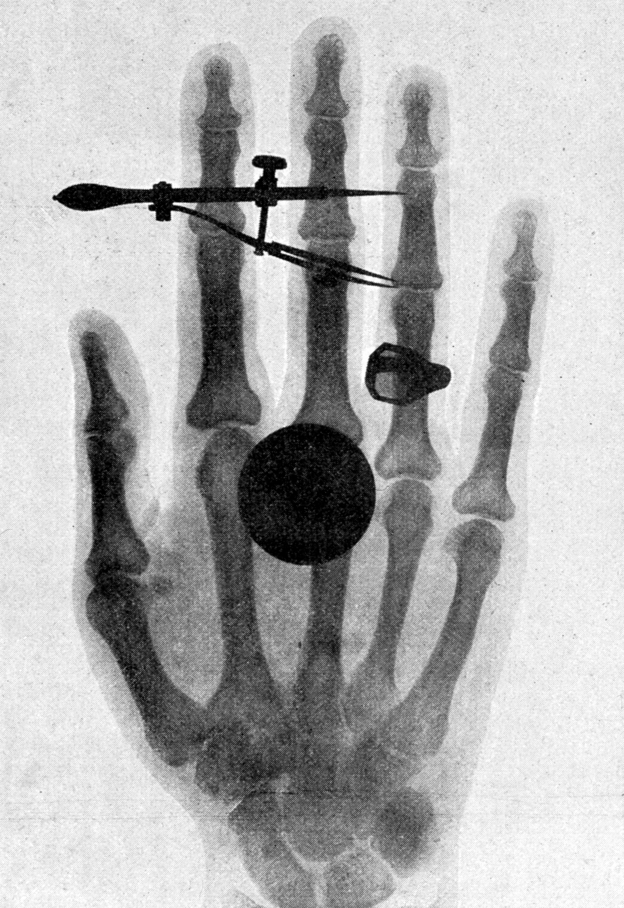
Soon after, he swapped the special screen for a photographic plate. (27)
This meant the internal structures of the body could be seen without the need
for surgery. One of Roentgen’s first photos was of his wife
Bertha’s hand. (28)
……..
The news of Roentgen’s discovery spread quickly. Scientists everywhere
tried out his experiment for themselves. In early 1896, X-rays were already
being used in the United States to investigate bone fractures. (29)
This was one of the first X-ray departments in the world. There was also a lot
of excitement about X-rays among the general public. (30) This largely
stopped, however, when people realised that X-rays could be dangerous.
Today, patients and doctors are protected from their harmful side effects.
……..
……..

A Machines were used in theatrical shows, for example, to show the inside of people’s bodies as entertainment.
B As this flowed through the tube, he noticed that light was coming out.
C He called it this because, in mathematics, this letter is used to indicate an unknown quantity.
D He realised that he had produced a previously unknown ‘invisible light’ that could pass through paper.
E In the image, all of the bones and her wedding ring are clearly visible.
F This tube is similar to the long cylinder-shaped lights found in many buildings.
G Around the same time, X-ray facilities were set up at a hospital in Glasgow, Scotland.
H He noticed that the more solid each thing was, the more of a shadow it created on the special screen.
I This allowed him to take pictures of the inside of objects he shone the ray through.
J He covered this with a special material that produces a green-coloured glow when strong light
falls on it.
[Total: 10 marks]

Writing
31 You see this announcement on an English language website:
Articles wanted
Tell us about the best place you’ve ever been to on holiday.
Where did you go?
Who did you go there with?
What did you do there?
Why did you enjoy it so much?
Write an article answering these questions and we’ll publish the best ones on our website.

Staying fit and healthy

Write your article in about 200 words in an appropriate style below.
……………………………………………………………………………………………………………………
……………………………………………………………………………………………………………………
……………………………………………………………………………………………………………………
……………………………………………………………………………………………………………………
……………………………………………………………………………………………………………………
……………………………………………………………………………………………………………………
……………………………………………………………………………………………………………………
……………………………………………………………………………………………………………………
……………………………………………………………………………………………………………………
……………………………………………………………………………………………………………………
……………………………………………………………………………………………………………………
……………………………………………………………………………………………………………………
……………………………………………………………………………………………………………………
……………………………………………………………………………………………………………………
……………………………………………………………………………………………………………………
……………………………………………………………………………………………………………………
……………………………………………………………………………………………………………………
……………………………………………………………………………………………………………………
……………………………………………………………………………………………………………………
……………………………………………………………………………………………………………………
……………………………………………………………………………………………………………………
……………………………………………………………………………………………………………………
……………………………………………………………………………………………………………………
……………………………………………………………………………………………………………………
……………………………………………………………………………………………………………………
……………………………………………………………………………………………………………………
……………………………………………………………………………………………………………………
……………………………………………………………………………………………………………………
……………………………………………………………………………………………………………………
……………………………………………………………………………………………………………………

[Total: 20 marks]

